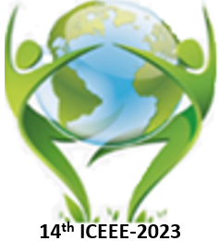 |  | The 14th ICEEE-2023 Online  International Annual Conference on  “Global Environmental Development & Sustainability: Research, Engineering & Management”

Date: 16th – 17th of November 2023, 9:00 a.m.

Location: Óbuda University. Budapest – Hungary

Application deadline: October 15th, 2023.

Please send the completed application form to bayoumi.hosam@uni-obuda.hu.

Please fill out the application form by machine!
First name:
Last (Family) name:
Nationality:
Workplace: University/Organization
Title: Mr. / Ms. / Miss
Eng. PhD student Dr. Prof
Academic Position:
Professional field (Specialty)
Qualification
Presentation type (Oral / Poster)
1st presentation (oral /poster) title:
Author(s)
2nd presentation (oral/poster) title:
Author(s)
Mailing address | Recipient name
 | City, Country
 | Street, building number
 | Postal code
E-mail:
Telephone/Mobile:
Selected Session  Please underline your session |  |  | Session (A) Healthcare: Risk & Management  Session (B) Soil Biology &Agricultural Land Uses  Session (C) Physicochemical Properties of Water & Sediments  Session (D) Circular Economy Strategy and Waste Management and Sustainable Energy Research & Applications  Session (F) Air Pollution and Ecosystems & Landscape

